INTERIM PROGRESS REPORT

on

AI-ENABLED IOT VIRTUAL LABORATORY

Submitted by
Justin Jacob Saju (RA2311053010097)
Agnihotram Chinmayanand (RA2311053010116)
B.V. Balanilavan (RA2311053010123)

Semester – VI
Academic Year: 2025-26

Under the supervision of
Dr. Elamaran E
Assistant Professor, Department of ECE



DEPARTMENT OF ELECTRONICS AND COMMUNICATION ENGINEERING

College of Engineering and Technology,

SRM Institute of Science and Technology
SRM Nagar, Kattankulathur – 603203, Kancheepuram District, Tamilnadu.

March 2026

Declaration

We hereby declare that the 21ECP302L Project report submitted in partial fulfilment for the award of the Degree of Bachelor of Technology is our original work and this project report has not formed the basis of any degree, diploma, associate-ship, fellowship or any other similar titles. It has not been submitted to any other university or institution for the award of any degree or diploma.

Justin Jacob Saju  (RA2311053010097) | :
Agnihotram Chinmayanand  (RA2311053010116) | :
B.V. Balanilavan  (RA2311053010123) | :
Project Supervisor  Dr. Elamaran E | :
INTERIM PROGRESS REPORT EVALUATION RUBRICS

Project Title : AI-Enabled IoT Virtual Laboratory
Project Code : 21ECP302L

Team Member : Justin Jacob Saju (RA2311053010097)
Agnihotram Chinmayanand (RA2311053010116)
B.V. Balanilavan (RA2311053010123)

Name of Evaluator : Dr. Elamaran E.

Rubrics | Possible Points | Assigned Marks
Rubrics | Possible Points | Reg No  RA2311053010097 | Reg No  RA2311053010116 | Reg No  RA2311053010123
Aim & Objectives, Abstract  - Objective complete and well-written  - provides all necessary background principles for the experiment | 5
Content-Introduction, Literature review, System model  Technically correct; Contain in-depth and complete details of the project | 10
Language (Word Choice, Grammar)  - Sentences are complete and grammatical. They flow together easily  - Words are chosen for their precise meaning.  - Engineering terms and jargon are used correctly; No misspelled words.  Numerical Usage and Illustrations  - All figures, graphs, charts, and drawings are accurate, consistent with the text, and of good quality. They enhance understanding of the text.  - All items are labelled and referred to in the text.  - All equations are clear, accurate, and labelled.  - All variables are defined and units specified.  - Discussion about the equation development and use is stated. | 5
Total Points | 20

Date:17/03/2026 Signature of the Project Guide
ABSTRACT

Traditional engineering laboratories require expensive equipment, physical presence, and continuous supervision by instructors. These limitations restrict accessibility and scalability of practical experimentation for students. To address these challenges, this project proposes an AI-Enabled IoT Virtual Sensor Laboratory that allows students to remotely monitor and analyse real-time sensor data through an online dashboard.
The proposed system integrates Internet of Things (IoT) hardware, Digital Twin simulation, and Artificial Intelligence-based diagnostics to create an interactive remote laboratory platform. Multiple sensors connected to an Arduino Mega 2560 microcontroller collect environmental and physical parameters such as temperature, gas concentration, light intensity, motion detection, and distance measurement. The data is transmitted through an ESP8266 Wi-Fi module to a cloud-based backend server developed using Node.js, where the information is processed and streamed to a Next.js web dashboard using WebSocket communication.

A digital twin model replicates the behaviour of physical sensors in the virtual environment, enabling real-time visualization and analysis of experimental data. Additionally, an AI inference engine analyses sensor patterns and identifies possible circuit faults such as floating pins, sensor calibration errors, and abnormal signal fluctuations. This feature helps students understand debugging and troubleshooting processes during experimentation.

The system also includes fault injection mechanisms that simulate real hardware errors such as stuck-at faults, random noise, and calibration drift. These capabilities allow students to study system behaviour under abnormal conditions and gain practical troubleshooting experience.
This project contributes to Sustainable Development Goal (SDG) 4 – Quality Education by providing an accessible digital laboratory platform that enables remote experimentation, enhances practical learning, and supports technology-driven engineering education. The project also supports Sustainable Development Goal (SDG) 9 – Industry, Innovation and Infrastructure by promoting innovative IoT-based educational infrastructure and encouraging the adoption of advanced technologies such as AI, digital twins, and smart monitoring systems in engineering laboratories.




Fig 1 SDG4 – Quality Education Fig 2 SDG9 – Industry, Innovation and
Infrastructure

LITERATURE SURVEY

S.  No | Title | Authors | Published Paper Type | Published Year | Findings
1 | Remote Experimentation Through Arduino-Based Remote Laboratories | Sergio Martin, Atilano Fernandez-Pacheco, José A. Ruipérez-Valiente, German Carro, Manuel Castro | Journals & Magazines > IEEE Revista Iberoamericana de Tecnologias del Aprendizaje > Volume 16, Issue 2, Pages 180–186 | May 2021 | Proposed a host-node remote lab architecture using Arduino Mega and Raspberry Pi with a makefile-driven OTA sketch upload pipeline. Students write Arduino code on a browser which compiles and executes on real hardware. Webcam streaming provides visual feedback. Limitation: no AI diagnostics or automated mistake detection.
2 | Implementation of a Sensor Node for Monitoring Physiological Signals with WebSocket Communication and Data Visualization in a Node.js Server over the Internet | Ricardo Yauri Rodriguez, Milton Rios Julcapoma | Conference Paper > IEEE > INICTEL-UNI, Lima, Peru | 2020 | Designed low-power ESP8266-based IoT sensor nodes for real-time ECG, temperature, and pulse monitoring. WebSocket communication via Node.js middleware achieved transmission latency of 25–39 ms. Demonstrated full-duplex browser visualization. Limitation: focused on physiological signals only with no educational or AI feedback layer.
3 | Preventing Data Integrity Breaches in IoT Applications Using Digital Twins | Mohammed El-Hajj | Conference Paper > IEEE > 23rd Mediterranean Communication and Computer Networking Conference (MedComNet) | 2025 | Proposed Digital Twin shadow models for real-time anomaly detection in IoT systems using Azure Digital Twins and AWS IoT TwinMaker. Achieved 70–85% reduction in attack success rates and detection latency of 142 ms versus 612 ms for traditional IDS. False positive rate reduced from 15.9% to 2.1%. Limitation: designed for industrial security, not educational environments.
4 | Digital Twins for Smart Spaces — Beyond IoT Analytics | Naser Hossein Motlagh, Martha Arbayani Zaidan, Lauri Lovén, Pak Lun Fung, Tuomo Hänninen, Roberto Morabito, Petteri Nurmi, Sasu Tarkoma | Journals & Magazines > IEEE Internet of Things Journal > Volume 11, Issue 1, Pages 573–583 | January 2024 | Proposed a four-layer reference architecture (Physical, Sensing, Networking, Computing) for smart space Digital Twins. Validated using 68 LoRaWAN sensor nodes at University of Oulu across 410 days. Demonstrated Descriptive, Diagnostic, and Predictive twin levels using CO2-PIR correlation analysis. Limitation: focused on building management, not student experimentation.
5 | Digital Twins Applications in STEM Education: Challenges and Implementation Opportunities in Developing Countries | Onélia Fernanda Caribo, Jean Claude Byungura, Louis Sibomana, Barbara Kabwiga Asingwire, Christine Niyizamwiyitira | Conference Paper > IEEE > Digital Education and MOOCs Conference (DEMOcon) | 2024 | Surveyed 342 secondary schools in Rwanda and Mozambique using Yamane sampling at 95% confidence. Found 33.3% of schools lack physical laboratories and 0% have virtual laboratories. Identified infrastructure, connectivity, access, and human resources as key DT adoption variables. Limitation: conceptual framework only with no physical IoT implementation.
6 | Exploring the Use of AI-Enhanced Virtual Labs for Engineering Education | Rakhmatjan Tadjikuziev, Shovkat Tursunov, Ma'rifat Ismailova, Shoirakhon Baybabaeva, Makhmudjon Shakhodjaev, Surayyo Mirzayeva | Conference Paper > IEEE > 3rd International Conference on IoT, Communication and Automation Technology (ICICAT) | 2025 | Evaluated AI-Enhanced Virtual Labs (AIVL) against Traditional Physical Labs and Standard Virtual Labs across 6,500 students in 10 universities. AIVL students scored 17.5–20% higher on exams and completed labs 35% faster. Student satisfaction reached 89.1%. Engagement and retention improved by 21.3% and 18.3% respectively. Limitation: purely simulation-based with no real hardware-in-the-loop verification.

SYSTEM MODEL DESCRIPTION
The proposed AI-Enabled IoT Virtual Sensor Laboratory is designed to enable remote experimentation and real-time monitoring of sensor data through a web-based platform. The system integrates IoT hardware, wireless communication, cloud processing, digital twin simulation, and artificial intelligence–based diagnostics to create an intelligent virtual laboratory environment.
The overall system architecture consists of six major layers: Sensor Layer, Embedded Processing Layer, Communication Layer, Cloud Processing Layer, and Visualization Layer.
1. Sensor Layer
The sensor layer forms the physical interface between the environment and the system. Multiple sensors are connected to the microcontroller to measure different environmental and physical parameters.
The sensors used in the system include:
Sensor | Function
DHT11 Sensor | Measures temperature and humidity
Thermistor Sensor | Measures temperature based on resistance variation
MQ-2 Gas Sensor | Detects combustible gases such as LPG and smoke
MQ-3 Alcohol Sensor | Detects alcohol vapors in the environment
LDR Sensor | Measures light intensity
PIR Motion Sensor | Detects human motion using infrared radiation
HC-SR04 Ultrasonic Sensor | Measures distance using ultrasonic waves
Flame Sensor | Detects fire or flame presence
Hall Effect Sensor | Detects magnetic field strength
Sound Sensor | Detects sound levels and acoustic vibrations
Tilt Sensor | Detects orientation or angular changes
Capacitive Touch Sensor | Detects touch input
Joystick Module | Provides two-axis analog input for user interaction and control
Inductive Proximity Sensor | Detects nearby metallic objects without physical contact
Table 1: List of sensors
These sensors generate either analog or digital signals, which are captured by the microcontroller. The collected signals represent environmental conditions and user interactions in the laboratory setup.
2. Embedded Processing Layer
The embedded processing layer consists of the Arduino Mega 2560 microcontroller, which acts as the central controller of the system.
The microcontroller performs the following tasks:
- Reads analog and digital signals from sensors
- Converts analog signals into digital values using the internal ADC
- Processes sensor measurements
- Formats sensor readings into structured data packets
- Sends the data to the communication module
The Arduino Mega 2560 is selected because it provides 54 digital I/O pins, 16 analog input pins, and multiple serial communication interfaces, making it suitable for handling a large number of sensors simultaneously.
3. Communication Layer
The communication layer enables wireless transmission of sensor data to the cloud server. In this system, an ESP8266 Wi-Fi module is used to provide internet connectivity.
The ESP8266 communicates with the Arduino Mega through UART serial communication and performs the following functions:
- Connects the system to a wireless network
- Receives processed sensor data from the microcontroller
- Transmits data to the backend server through HTTP requests
- Maintains continuous communication for real-time monitoring
This layer enables reliable data transmission between the physical laboratory setup and the online monitoring system.
4. Cloud Processing Layer
The cloud processing layer consists of a Node.js backend server that receives and processes the sensor data transmitted by the ESP8266 module.
The server performs several operations including:
- Receiving sensor data through API endpoints
- Processing and managing incoming data streams
- Broadcasting real-time data using WebSocket communication (Socket.io)
- Maintaining experiment sessions and system status
An AI inference engine integrated with the backend analyses sensor data patterns and detects abnormal system behaviour such as:
- Floating pins in digital circuits
- Sensor calibration errors
- Unusual signal oscillations
- Abnormal environmental readings
The AI system generates diagnostic alerts that assist students in identifying potential circuit or sensor issues.
5. Visualization and Digital Twin Layer
The visualization layer is implemented using a Next.js web dashboard, which allows users to monitor experiments remotely.
The dashboard provides:
- Real-time sensor data visualization through graphs
- Monitoring of multiple sensors simultaneously
- Alerts generated by the AI diagnostic system
- Interactive controls for experiment observation
A digital twin model is implemented within the dashboard to simulate the behaviour of the physical sensors in a virtual environment. This allows students to compare real hardware readings with virtual models for better understanding of system behaviour.
6. Fault Injection Module
To enhance the learning experience, the system includes a fault injection module that simulates hardware faults commonly encountered in electronic circuits.
The simulated faults include:
- Stuck-at-Low Fault – sensor output fixed at a low value
- Stuck-at-High Fault – sensor output fixed at a high value
- Open Circuit Fault – sensor disconnected from the system
- Random Noise Injection – signal disturbances in sensor readings
- Calibration Drift – gradual deviation in sensor measurements
These fault scenarios allow students to observe abnormal system behavior and develop practical debugging skills.
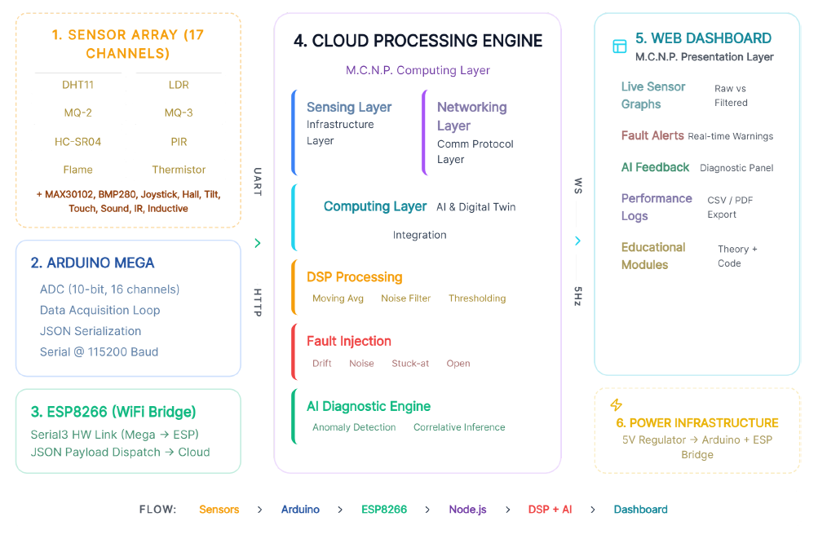
Fig 3 - Architecture of the M.C.N.P. Digital Twin Framework

Statement of Contribution
This interim progress report and the associated project activities have been carried out collaboratively by all the team members. Each member has contributed equally to the research, development, testing, and documentation of the proposed system.
1. Justin Jacob Saju (RA2311053010097)
- Led hardware implementation including sensor interfacing, pin assignment, and Arduino Mega 2560 firmware development
- Designed and implemented the Digital Twin simulation engine and physics-based mock data generation model
- Conducted end-to-end system integration testing and validated real-time data accuracy across all sensor channels
2. Agnihotram Chinmayanand (RA2311053010116)
- Conducted literature survey, analysed related research papers, and identified the research gap addressed by this project
- Designed the AI Inference Engine including rule-based anomaly detection, floating pin identification, and cross-sensor correlation logic
- Contributed to system architecture design and preparation of project report documentation
3. B.V. Balanilavan (RA2311053010123)
- Developed the Node.js backend server, REST API endpoints, and real-time WebSocket broadcasting using Socket.io
- Implemented the Next.js web dashboard including live sensor visualization, fault injection controls, and AI diagnostic display
- Managed cloud deployment on Vercel and Render and verified system performance under live operating conditions

